***PAAREES PERFUMES***

***DAVIDOFF***

***FOR MEN***

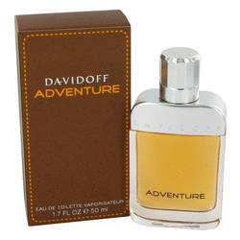

# 

***Davidoff Adventure***

***Description:***

Davidoff Adventure by Davidoff Cologne. Get ready for a new adventure every day that you dab on this fresh, spicy men's fragrance created by Davidoff. Designed for the thrill-seeking man who loves the outdoors, this inspiring fragrance greets you with fresh hints of tea leaf that blend perfectly with notes of juicy lemon, mandarin orange and bergamot. Bold traces of pepper finish off this masculine aroma that first became available in 2008. Enhance your daily wear with this rich Davidoff Adventure fragrance and you are sure to make a lasting impression.